**DAILY ONLINE ACTIVITIES SUMMARY**

|  |  |  |  |  |  |  |  |  |
| --- | --- | --- | --- | --- | --- | --- | --- | --- |
| **Date:** | **30/05/2020** | | | | | **Name:** | **Chandana Patil** | |
| **Sem & Sec** | **6th Sem and A Sec** | | | | | **USN:** | **4AL17CS020** | |
| **Online Test Summary** | | | | | | | | |
| **Subject** | | **PAP-II** | | | | | | |
| **Max. Marks** | | **30** | | **Score** | | | **10** | |
| **Certification Course Summary** | | | | | | | | |
| **Course** | **Introduction to Cyber Security** | | | | | | | |
| **Certificate Provider** | | | **Greatlearning** | | **Duration** | | | **7 Hours** |
| **Coding Challenges** | | | | | | | | |
| **Problem Statement:**  **1.** Python program to read a number and print the pattern.  **2.** Write a java program to Count number of trailing zeros in product of array. | | | | | | | | |
| **Status: Completed** | | | | | | | | |
| **Uploaded the report in Github** | | | | | **yes** | | | |
| **If yes Repository name** | | | | | **https://github.com/chandanapatil/OnlineCourse.git** | | | |
| **Uploaded the report in slack** | | | | | **Yes** | | | |

**Online Test:**

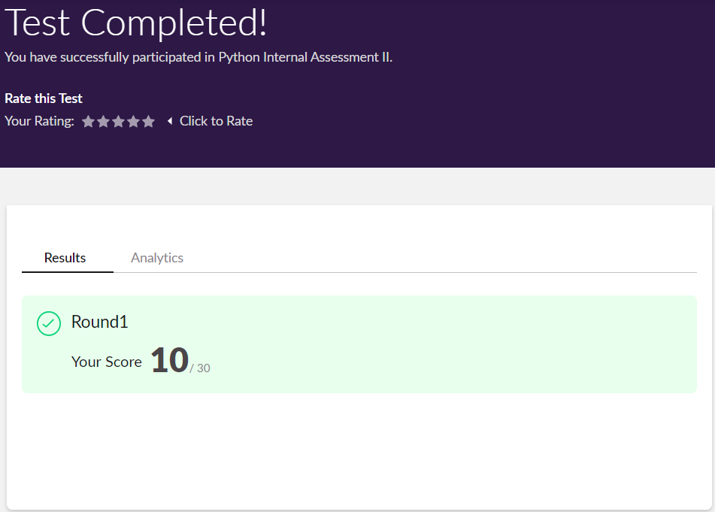

**Certification:** 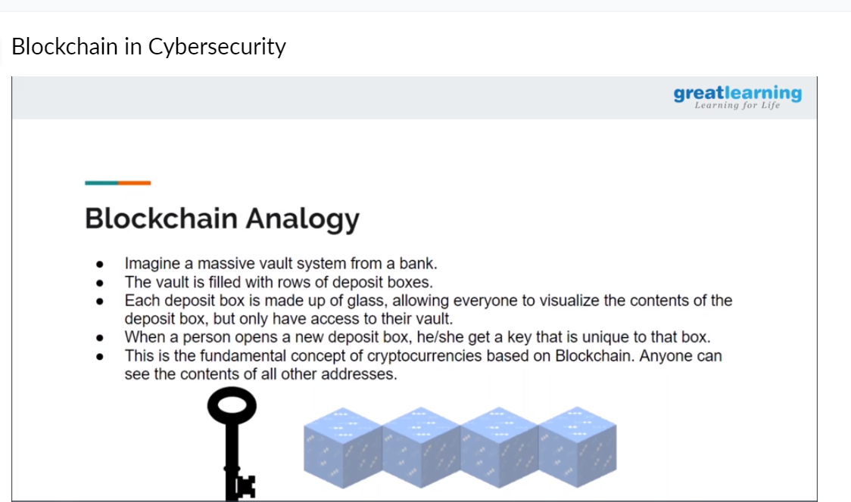

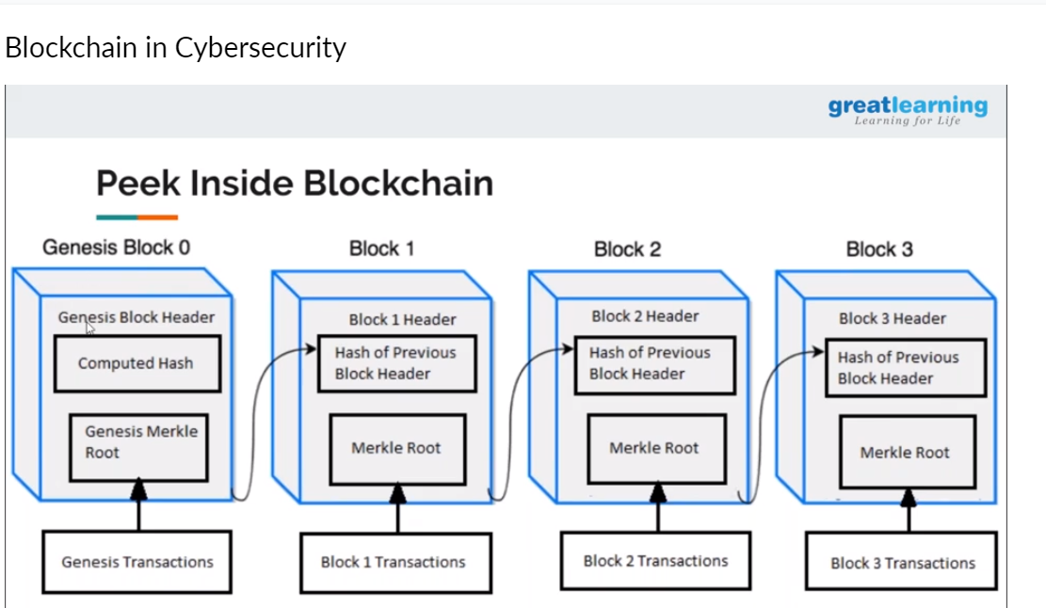

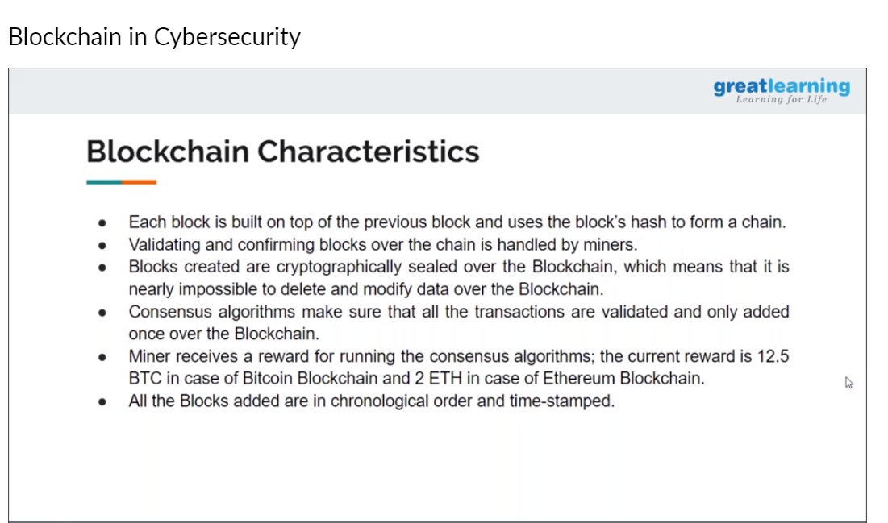

**OnlineCoding:**

**Prog1:** Python program to read a number and print the pattern.

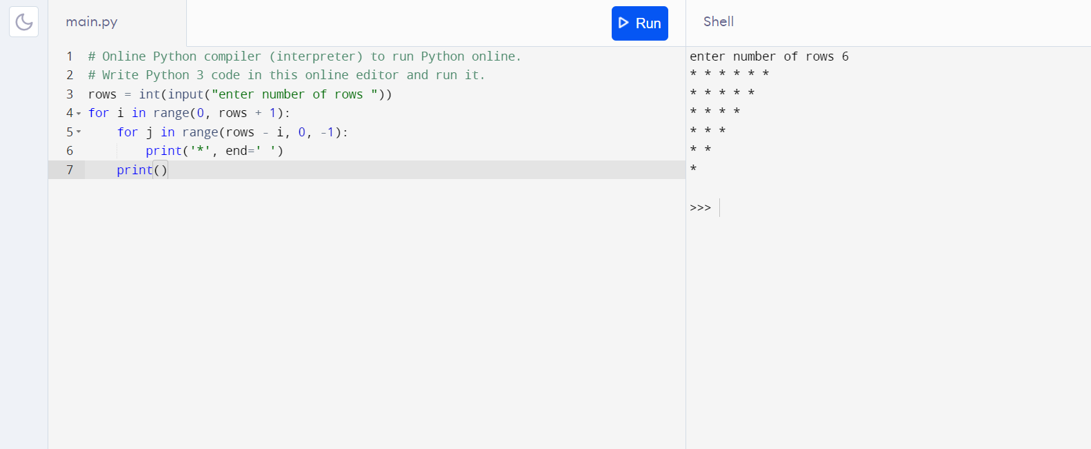

**Prog2:** Write a java program to Count number of trailing zeros in product of array.

